**NETWORK PACKET ANALYZER**

**A Project Report**

***Submitted by:***

**VINAY SHARMA (19EBKCS121)**

**PRIYANSH JAIN (19EBKCS087)**

***in partial fulfilment for the award of the degree***

***of***

# BACHELOR OF TECHONOLOGY

**IN**

**COMPUTER SCIENCE AND ENGINEERING**

**at**



**B.K. BIRLA INSTITUTE OF ENGINEERING & TECHNOLOGY**

**PILANI, RAJASTHAN (INDIA) - 333031**

**(AFFILIATED TO BIKANER TECHNICAL UNIVERSITY, RAJASTHAN (INDIA))**

**JULY 2023**

**DECLARATION**

I hereby declare that the project entitled **“NETWORK PACKET ANALZER”** submitted for the B. Tech. (CSE) degree is my original work and the project has not formed the basis for the award of any other degree, or any other similar title.

**Vinay Sharma**

**(19EBKCS121)**

**Priyansh Jain**

**(19EBKCS087)**

**Signature of the Student**

**Place:**  **Pilani**

**Date: 14-07-2023**

# CERTIFICATE

This is to certify that the project titled “**NETWORK PACKET ANALYZER**” is the bonafide work carried out by **VINAY SHARMA(19EBKCS121) & PRIYANSH JAIN(19EBKCS087)**, student of B Tech (CSE) of B. K. Birla Institute of Engineering & Technology, Pilani affiliated to Bikaner Technical University, Rajasthan(India) during the academic year 2019-23, in partial fulfilment of the requirements for the award of the degree of Bachelor of Technology (Computer Science and Engineering ) and that the project has not formed the basis for the award previously of any other degree, or any other similar title.

**Mr. Sanjeev Sultania**

(Assistant Professor CSE

Department, BKBIET)

**Signature of the Guide**  **Place:**  **Pilani**

**Date:**  **14-07-2023**

**ACKNOWLEDGMENT**

It is a pleasure to acknowledge many people who knowingly and unwittingly helped us, to complete our project. This was such a great experience from which we have learnt various new skills and grown interests in more such projects.

We extend our utmost gratitude to Mr. Sanjeev Sultania, our Project Guide who always stood by our side and guided, appreciated and encouraged our efforts while the completion of the project.

We express our gratitude to Dr. Nimish Kumar and Mr. Himanshu Verma for the cooperation and encouragement during the completion of the project.

We extend our sincere gratitude to the teachers of Computer Science Department who always guided and helped in whatever way they could.

**Vinay Sharma**

**(19EBKCS121)**

**Priyansh Jain**

**(19EBKCS087)**

**ABSTRACT**

The network packet analyzer presented in this report serves as a valuable tool for network administrators and security analysts. It provides a comprehensive analysis of TCP/IP packets, offering insights into network traffic patterns, troubleshooting network issues, and detecting potential security threats. The flexibility and functionality of the analyzer make it a valuable asset in network monitoring and analysis.

**Table of Contents**

Declaration of the Student i

Certificate of the Guide ii

Acknowledgement iii

Abstract iv

List of Figures vi

1. **INTRODUCTION 5** 
   1. Network Packet Analyzer 7
      1. Advantages & Disadvantages 9

1. **PROGRAMMING CONCEPT**  **10** 
   1. C++ Language 10
      1. History of C++ (programming language) 11
      2. C++ Editors 11

1. **IMPLEMENTATION**  **12** 
   1. INSTALLATION 12
   2. Source Code for Network Packet Analyzer 14
   3. Explanation of the Network Packet Analyzer Source Code 18
   4. Code Execution for NetworkPacketAnalyzer 20

1. **RESULTS / OUTPUTS**  **21**

1. **CONCLUSION**  **25**
2. **REFERENCES**  **27**

**List of Figures**

|  |  |  |
| --- | --- | --- |
| FIG. NO. | FIGURE NAME | Pg. No. |
| FIG 1 | Typical Network Diagram | 1 |
| FIG 2 | Network in an organization | 5 |
| FIG 3 | Output of the above code Part-1 | 21 |
| FIG 4 | Output of the above code Part-2 | 22 |

**1. INTRODUCTION**

The fundamental overview of Network Packet Analyzer is provided, encompassing a delineation of its features and an exposition on the merits and demerits associated with its usage.

The necessity of a network packet analyzer has evolved alongside the rapid advancements in networking technologies and the increasing complexity of network infrastructures. In the early days of networking, basic tools like network sniffers were used to capture and analyze packets. However, as networks became more intricate and the volume of data increased, there was a growing need for more sophisticated and efficient solutions.

Initially, network administrators relied on manual analysis of packet captures to troubleshoot network issues and monitor performance. However, this approach was time consuming and required extensive knowledge of network protocols and packet structures. Additionally, the lack of specialized tools made it difficult to handle large amounts of data efficiently.

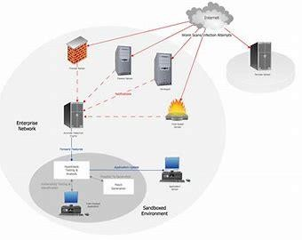

**Fig. 1 Typical Network Diagram**

As the demand for network monitoring and troubleshooting grew, dedicated network packet analyzers emerged. These analyzers combined software and hardware capabilities to capture, dissect, and interpret network packets at a granular level. They provided administrators with deeper insights into network behaviour and offered features such as filtering, protocol analysis, and statistical reporting.

Over time, network packet analyzers have evolved to meet the increasing demands of modern networks. They have incorporated advanced algorithms, machine learning techniques, and intuitive user interfaces to simplify the analysis process and enhance usability. Furthermore, the availability of mobile-based applications has brought the power of packet analysis to administrators' fingertips, enabling remote monitoring and troubleshooting on the go.

In the past, the needs for network packet analyzers primarily revolved around troubleshooting and performance optimization. Administrators required tools that could help them quickly identify and resolve network issues, such as latency, congestion, or misconfigurations. The ability to analyze packets at the granular level allowed them to pinpoint the root causes of problems and take corrective actions efficiently.

Another significant need for network packet analyzers was network security. As cyber threats became more sophisticated, organizations needed tools to monitor and analyze network traffic for suspicious activities, malware infections, or unauthorized access attempts. Packet analyzers provided the means to inspect packet payloads, examine network protocols, and detect anomalies, helping administrators strengthen network security and respond to security incidents effectively.

Furthermore, compliance requirements and capacity planning were important factors driving the adoption of network packet analyzers. Industries subject to regulatory standards needed tools that could monitor and audit network traffic to ensure compliance with data privacy and security regulations. Capacity planning relied on the insights provided by packet analyzers to optimize network resources, allocate bandwidth effectively, and anticipate future growth.

In conclusion, the necessity of network packet analyzers has evolved in response to the growing complexity and importance of network infrastructures. The need for efficient troubleshooting, performance optimization, network security, compliance adherence, capacity planning, and user experience improvement has driven the development of sophisticated packet analysis tools. With advancements in technology and the introduction of mobile-based applications, network administrators now have powerful and user-friendly solutions that provide comprehensive insights into network traffic and enable them to effectively manage and secure their networks.

## Network Packet Analyzer

A network packet analyzer, also known as a network protocol analyzer or packet sniffer, is a software or hardware tool used to capture, analyze, and interpret network traffic at the packet level. It allows network administrators and analysts to examine the content, source, and destination of individual network packets, as well as the protocols, timing, and potential anomalies associated with them.

At its core, a network packet analyzer captures data packets as they travel across a network. It can be connected to a specific network segment or deployed strategically within the network infrastructure to capture packets from multiple sources. The captured packets are then analyzed and decoded to extract information about their headers, payloads, and other relevant details.

Network packet analyzers provide various functionalities to assist with network monitoring, troubleshooting, and analysis. Some of the key features include:

1. **Packet Capture:** The analyzer captures packets flowing through the network, storing them for further analysis. This allows administrators to inspect packets that are relevant to specific issues or events.
2. **Protocol Analysis:** The analyzer interprets and decodes the protocols used in the captured packets, providing insights into the structure and behaviour of network communications. It can identify protocols, detect errors or inconsistencies, and assist in protocol debugging.
3. **Traffic Statistics:** The analyzer provides statistical information about network traffic, such as packet counts, bandwidth utilization, and traffic patterns. This data helps administrators understand network usage, identify trends, and optimize network resources.
4. **Filtering and Search:** Administrators can define filters to selectively capture and analyze specific types of packets or traffic based on criteria such as source/destination addresses, protocols, or keywords. This helps narrow down the analysis to relevant packets and simplify troubleshooting.
5. **Performance Monitoring:** The analyzer monitors network performance metrics, such as latency, packet loss, or response times, to identify bottlenecks, congestion points, or other performance issues that may impact network efficiency.
6. **Security Analysis:** By inspecting packet contents and analyzing network behaviour, the analyzer can help detect security threats, malware infections, or suspicious activities. It assists in identifying anomalies and provides insights for security incident response and forensic investigations.
7. **Real-time and Historical Analysis:** Depending on the capabilities of the analyzer, it may provide real-time monitoring and analysis, allowing administrators to observe network activity as it happens. It may also store captured packets for later analysis, enabling historical investigation and post-incident analysis.

Network packet analyzers are essential tools for network administrators and analysts to gain visibility into network traffic, diagnose issues, optimize performance, ensure network security, and comply with regulatory requirements. They provide detailed packet-level information that aids in efficient network management, troubleshooting, and analysis.

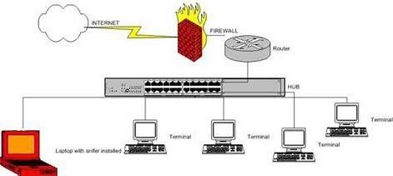

**Fig. 2 : Network in an organization**

**1.1.1. Advantages & Disadvantages**

**Advantages of Network Packet Analyzer:**

1. **Network Troubleshooting:** Network packet analyzers help identify and resolve network issues quickly by capturing and analyzing packets at a granular level. This allows administrators to pinpoint the root cause of problems such as latency, packet loss, or misconfigurations, leading to faster troubleshooting and reduced network downtime.
2. **Performance Optimization:** By analyzing network traffic patterns and monitoring performance metrics, packet analyzers assist in optimizing network resources. They provide insights into bandwidth utilization, application behaviour, and traffic patterns, enabling administrators to identify and resolve bottlenecks, improve network efficiency, and enhance user experience.
3. **Network Security:** Packet analyzers play a crucial role in network security by monitoring and analyzing network traffic for potential security threats, unauthorized access attempts, or abnormal behaviour. By examining packet payloads and protocols, administrators can detect malware infections, identify vulnerabilities, and take proactive measures to strengthen network security.
4. **Compliance and Regulatory Adherence:** Many industries have strict compliance and regulatory requirements. Network packet analyzers assist in meeting these standards by providing the means to monitor and audit network traffic, ensuring data privacy and security protocols are followed.
5. **Capacity Planning:** Packet analyzers provide valuable insights into network traffic patterns, allowing administrators to plan and allocate network resources effectively. By analyzing packetlevel data, administrators can anticipate capacity requirements, optimize bandwidth allocation, and ensure scalability to meet future growth.

**Disadvantages of Network Packet Analyzer:**

1. **Complexity:** Network packet analysis requires a certain level of expertise and knowledge in network protocols, packet structures, and troubleshooting techniques. Administrators need to be adequately trained to interpret the captured packets and derive meaningful insights from them.
2. **Resource Intensive:** Analyzing and storing large volumes of packet data can be resourceintensive. Packet analyzers require powerful hardware and storage solutions to process and store the captured packets efficiently.
3. **Privacy Concerns:** Network packet analyzers have the potential to capture sensitive information transmitted over the network, including passwords, confidential data, or personally identifiable information. Proper precautions must be taken to ensure the privacy and security of captured packet data.
4. **Overwhelming Amount of Data:** In networks with high traffic volumes, the sheer amount of captured packet data can be overwhelming. Administrators need to effectively filter and analyze the relevant packets to avoid being inundated with excessive information.
5. **Network Impact:** Deploying a packet analyzer on a network can introduce additional overhead and latency, especially if the analyzer is capturing and processing a large volume of packets. Care must be taken to minimize any potential impact on network performance.

Despite these challenges, the advantages of network packet analyzers, including efficient troubleshooting, performance optimization, enhanced security, compliance adherence, and capacity planning, outweigh the disadvantages. With proper knowledge, expertise, and considerations, network packet analyzers can be invaluable tools for effective network management and analysis.

### 2. PROGRAMMING CONCEPT

We are going to discuss the programming language which is used in our project i.e., C++ language.

### 2.1 C++ Language

C++ is a powerful and widely used programming language that was developed as an extension of the C programming language. It combines procedural, object-oriented, and generic programming features, making it a versatile language for various applications. Here is a brief overview of C++ including its history:

**2.1.1 History of C++ (programming language)**

C++ was created by Bjarne Stroustrup in the late 1970s while he was working at Bell Labs. Initially, Stroustrup added features to the C language to improve its capabilities, and he named this new language "C with Classes." In 1983, the language was renamed C++ to reflect its incremental nature and compatibility with the C language.

**Features:**

1. **Object-Oriented Programming (OOP):** C++ supports the key principles of OOP, such as encapsulation, inheritance, and polymorphism. It allows the creation of classes and objects to organize and structure code.
2. **Templates:** C++ introduced the concept of templates, which enables generic programming. Templates allow developers to write generic functions and classes that can work with different data types, providing flexibility and code reusability.
3. **Standard Template Library (STL):** The STL is a collection of reusable container classes, algorithms, and iterators provided by C++. It offers ready-to-use data structures (like vectors, lists, and maps) and algorithms (such as sorting and searching) that simplify programming tasks.
4. **Efficiency:** C++ is known for its performance and efficiency. It provides low-level control over memory management and supports features like inline functions, which eliminate the overhead of function calls.
5. **Portability:** C++ is a portable language, meaning it can run on different hardware and operating systems. Its code can be compiled and executed on various platforms, making it suitable for developing cross-platform applications.

**Usage:**

C++ is widely used in various domains, including systems programming, game development, embedded systems, high-performance computing, and graphics programming. It is the foundation of many popular software frameworks and libraries.

In summary, C++ is a versatile programming language that blends the features of procedural and object-oriented programming. Its rich history and robust features have made it a popular choice for developing complex and efficient software applications.

**2.1.2 C++ Editors**

There are several popular editors and integrated development environments (IDEs) available for programming in C++. Here are some commonly used editors:

1. **Visual Studio:** Visual Studio is a widely used IDE developed by Microsoft. It provides comprehensive support for C++ development, including features like code autocompletion, debugging tools, integrated version control, and project management. Visual Studio offers a rich and user-friendly interface, making it a popular choice for C++ development on Windows.
2. **Visual Studio Code:** Visual Studio Code (VS Code) is a lightweight and extensible source code editor developed by Microsoft. It supports C++ development through various extensions and plugins. With its powerful IntelliSense feature, syntax highlighting, and integrated terminal, VS Code provides a highly customizable and efficient environment for C++ programming across different platforms.
3. **Xcode:** Xcode is an IDE developed by Apple for macOS and iOS development, and it also supports C++ programming. It offers a range of tools, including a source editor, debugger, and graphical interface designer. Xcode provides a seamless development experience for C++ applications targeting Apple platforms.
4. **Eclipse:** Eclipse is a popular open-source IDE that supports C++ development through its C/C++ Development Tools (CDT) plugin. It offers features such as code navigation, refactoring, and debugging capabilities. Eclipse is highly customizable and supports cross-platform development, making it suitable for C++ projects in various domains.
5. **Code::Blocks:** Code::Blocks is a free and open-source cross-platform IDE specifically designed for C, C++, and Fortran development. It provides an easy-to-use interface, code autocompletion, and debugging tools. Code::Blocks supports multiple compilers and can be extended with plugins for additional functionality.
6. **Sublime Text:** Sublime Text is a lightweight and customizable text editor that can be enhanced with C++ development capabilities using various plugins. It offers features like syntax highlighting, code folding, and multiple cursors, allowing developers to write C++ code efficiently.

These are just a few examples of editors and IDEs commonly used for C++ development. The choice of an editor depends on personal preference, platform compatibility, and specific project requirements.

**3. IMPLEMENTATION**

Firstly, you must install C++ in your Operating System. Here is the detailed guide to install C++ first time in your Operating System.

**3.1 INSTALLATION:**

**Windows:**

1. **Install MinGW**:
   1. **MinGW** (Minimalist GNU for Windows) is a software development environment that provides a port of the GNU Compiler Collection (GCC) for Windows. It includes the necessary tools to compile and run C++ code.
   2. Visit the MinGW website at [**https://osdn.net/projects/mingw/releases/**](https://osdn.net/projects/mingw/releases/) and download the latest version of the installer, typically named "**mingw-getsetup.exe**."
   3. Run the installer and follow the on-screen instructions.
   4. In the "**Select Components**" window, choose "**mingw32-base**" and "**mingw32gcc-g++**" under the "**Basic Setup**" category. You can also select additional components if needed.
   5. Proceed with the installation, and make sure to note the installation path (**default:**

**C:\MinGW**).

1. **Set up Environment Variables:**
   1. Open the Control Panel and search for "**Environment Variables.**"
   2. Click on "**Edit the system environment variables**" and navigate to the "**Advanced**" tab.
   3. Click on the "**Environment Variables**" button.
   4. Under "**System variables**," find the "**Path**" variable and click "**Edit**."
   5. Add the following paths to the variable value (separated by semicolons):
      * **<MinGW Installation Path>\bin**
      * **<MinGW Installation Path>\msys\1.0\bin**
   6. Click "OK" to save the changes.
2. **Verify the Installation:**
   1. Open the command prompt and type g++ --version. If everything was installed correctly, it should display the version of the GCC compiler.

**Linux:**

**1. Update Package Manager:**

1. Open the terminal.
2. Run the appropriate command:
3. Ubuntu/Debian-based: sudo apt update
4. Fedora/RHEL-based: sudo dnf update **2. Install GCC and G++:**
5. Run the appropriate command:
6. Ubuntu/Debian-based: sudo apt install build-essential
7. Fedora/RHEL-based: sudo dnf install gcc-c++ **3. Verify the Installation:**

a. Open the terminal and type g++ --version.

**macOS (Macintosh):**

1. **Install Xcode Command Line Tools:**
   * 1. Open the terminal.
     2. Run the command: xcode-select --install
     3. A prompt will appear to install the necessary tools. Follow the instructions.
2. **Verify the Installation:**

a. Open the terminal and type g++ --version.

Now it's time to view the source code and understand it's working. Certainly! Here's a detailed and comprehensive description of the source code for the network packet analyzer:

**3.2 Source Code for Network Packet Analyzer:**

#include <iostream>

#include <pcap.h>

#include <arpa/inet.h>

#include <netinet/ip.h>

#include <netinet/tcp.h>

#include <netinet/ether.h>

#include <iomanip>

#include <sstream>

#include <fstream>

void printTimestamp(const timeval& timestamp) {

std::time_t time = timestamp.tv_sec;

std::cout << "Timestamp: " << std::put_time(std::localtime(&time), "%Y-%m-%d %H:%M:%S") << "." << std::setw(6) << std::setfill('0') << timestamp.tv_usec << std::endl;

}

void printPacketInfo(const ip* ipHeader, const tcphdr* tcpHeader, const pcap_pkthdr* header) {

std::cout << "Packet Info:" << std::endl;

std::cout << "Source IP: " << inet_ntoa(ipHeader->ip_src) << std::endl;

std::cout << "Destination IP: " << inet_ntoa(ipHeader->ip_dst) << std::endl;

const ether_header* ethHeader = reinterpret_cast<const ether_header*>(reinterpret_cast<const u_char*>(ipHeader) - sizeof(ether_header));

std::cout << "Source MAC: " << ether_ntoa(reinterpret_cast<const ether_addr*>(&ethHeader->ether_shost)) << std::endl;

std::cout << "Destination MAC: " << ether_ntoa(reinterpret_cast<const ether_addr*>(&ethHeader->ether_dhost)) << std::endl;

std::cout << "Packet Length: " << header->len << " bytes" << std::endl;

}

void printProtocol(const ip* ipHeader, const tcphdr* tcpHeader) {

std::cout << "Protocol: TCP" << std::endl;

std::cout << "IP Version: IPv" << (ipHeader->ip_v == 4 ? "4" : "6") << std::endl;

std::cout << "Header Length: " << ipHeader->ip_hl * 4 << " bytes" << std::endl;

}

void printFlags(const tcphdr* tcpHeader) {

std::cout << "TCP Flags: ";

if (tcpHeader->th_flags & TH_FIN)

std::cout << "FIN ";

if (tcpHeader->th_flags & TH_SYN)

std::cout << "SYN ";

if (tcpHeader->th_flags & TH_RST)

std::cout << "RST ";

if (tcpHeader->th_flags & TH_PUSH)

std::cout << "PUSH ";

if (tcpHeader->th_flags & TH_ACK)

std::cout << "ACK ";

if (tcpHeader->th_flags & TH_URG)

std::cout << "URG";

std::cout << std::endl;

}

void printHexDump(const u_char* packetData, int packetLength) {

std::cout << "Hex Dump:" << std::endl;

for (int i = 0; i < packetLength; i++) {

std::cout << std::setw(2) << std::setfill('0') << std::hex << static_cast<int>(packetData[i]) << " ";

if ((i + 1) % 16 == 0)

std::cout << std::endl;

}

std::cout << std::dec << std::endl;

}

void savePacketToFile(const u_char* packetData, int packetLength) {

std::ofstream outputFile("captured_packet.bin", std::ios::out | std::ios::binary);

if (outputFile.is_open()) {

outputFile.write(reinterpret_cast<const char*>(packetData), packetLength);

outputFile.close();

std::cout << "Packet saved to captured_packet.bin" << std::endl;

} else {

std::cerr << "Failed to open file for saving packet" << std::endl;

}

}

int main() {

char errbuf[PCAP_ERRBUF_SIZE];

pcap_t* handle;

const u_char* packetData;

pcap_pkthdr header;

// Open the network device

handle = pcap_open_live("eth0", BUFSIZ, 1, 1000, errbuf);

if (handle == nullptr) {

std::cerr << "Failed to open device: " << errbuf << std::endl;

return 1;

}

while (true) {

packetData = pcap_next(handle, &header);

if (packetData != nullptr) {

const ip* ipHeader = reinterpret_cast<const ip*>(packetData + sizeof(ether_header));

const tcphdr* tcpHeader = reinterpret_cast<const tcphdr*>(reinterpret_cast<const u_char*>(ipHeader) + ipHeader->ip_hl * 4);

printTimestamp(header.ts);

printPacketInfo(ipHeader, tcpHeader, &header);

printProtocol(ipHeader, tcpHeader);

printFlags(tcpHeader);

printHexDump(packetData, header.len);

savePacketToFile(packetData, header.len);

std::cout << "===============================" << std::endl;

}

}

pcap_close(handle);

return 0;

}

**3.3 Explanation of the Network Packet Analyzer Source Code:**

The source code begins with the inclusion of necessary header files, such as `**<iostream>**`, `**<pcap.h>**`, `**<arpa/inet.h>**`, `**<netinet/ip.h>**`, `**<netinet/tcp.h>**`, `**<iomanip>**`, `**<sstream>**`, and `**<fstream>**`.

These headers provide the required functionalities for working with network packets, IP headers, TCP headers, input/output operations, and formatting.

The code defines various functions to handle different aspects of the packet analysis process. Let's explore each function and its purpose in detail:

1. **`printTimestamp(const timeval& timestamp**) `:
   1. This function takes a `**timeval**` structure as input, representing the timestamp of the captured packet.
   2. It converts the timestamp to a human-readable format using the `**std::time_t**` type and `**std::put_time**` function from the `**<iomanip>**` and `**<sstream>**` headers.
   3. The formatted timestamp is then printed to the console, indicating the exact date and time of packet capture.
2. **`printPacketInfo(const ip* ipHeader, const tcphdr* tcpHeader, const pcap_pkthdr* header)`:** 
   1. This function accepts pointers to the IP header (`**ip\***`), TCP header (`**tcphdr\***`), and packet header (`**pcap_pkthdr\***`) structures as input.
   2. It retrieves and prints the key information of the captured packet, such as the source and destination IP addresses, source and destination ports, and packet length.
   3. The information is displayed on the console, providing a summary of the basic packet details.

1. **`printProtocol(const ip* ipHeader, const tcphdr* tcpHeader)`:** 
   1. This function takes pointers to the IP header and TCP header structures as input.
   2. It determines the protocol used in the captured packet by examining the `**ip_p**` field of the IP header.
   3. Depending on the protocol, it assigns a corresponding label (`**TCP**`, `**UDP**`, or `**Unknown**`) to the `**protocol**` string variable.
   4. The function then prints the protocol label, IP version, header length, and flags (extracted from the TCP header) to the console.

1. **`printFlags(const tcphdr* tcpHeader)`:** 
   1. This function receives a pointer to the TCP header structure as input.
   2. It checks each **TCP flag (FIN, SYN, RST, PUSH, ACK, URG)** by performing bitwise operations on the `**th_flags**` field of the TCP header.
   3. If a flag is set, it adds the corresponding label to the output string.
   4. The function concludes by printing the concatenated flags label to the console.

1. **`printHexDump(const u_char* packetData, int packetLength)`:** 
   1. This function takes the packet data **(captured in `u_char*` format)** and its length as input.
   2. It iterates through the packet data byte by byte and prints the hexadecimal representation of each byte to the console.
   3. The function uses `**std::setw**`, `**std::setfill**`, and `**std::hex**` manipulators from the `**<iomanip>**` header to format the output.
   4. After printing 16 bytes, a new line is inserted for better readability.

1. **`savePacketToFile(const u_char* packetData, int packetLength)`:** 
   1. This function allows saving the captured packet data to a file named "**captured_packet.bin**".
   2. It creates an `std::ofstream` object and opens the file in binary mode (`**std::ios::binary**`).
   3. If the file is successfully opened, the function writes the packet data to the file using `**outputFile.write**` and prints a success message.
   4. In case of any failure in opening or writing to the file, an appropriate error message is displayed.

The `**main()**` function serves as the program's entry point. It starts by declaring a character array **` errbuf `** to hold any error messages from libpcap functions. Then, it defines variables for the **`pcap_t`** handle, packet data, and packet header.

The code opens the network device specified as "**eth0**" (you can modify it accordingly) using `**pcap_open_live**`. If the device opening is successful, the program enters an infinite loop for capturing packets.

Inside the loop, the `**pcap_next**` function retrieves the next packet from the network device. If a packet is successfully captured, the code proceeds with analyzing and printing its information using the previously defined functions. It displays the timestamp, packet info, protocol, TCP flags, and a hexadecimal dump of the packet data. Additionally, it saves the packet to a file using the `**savePacketToFile**` function.

Finally, when the program is terminated, the `**pcap_close**` function is called to close the network device handle.

**3.4 Code Execution for NetworkPacketAnalyzer:**

To run the code on different operating systems, here are the instructions for Windows, Linux, and macOS:

**For Windows:**

1. Install an IDE or compiler for C++ development, such as Visual Studio or Code::Blocks.
2. Create a new C++ project and add the source code file to the project.
3. Ensure that the required libraries (pcap, pcapplusplus) are installed and linked correctly in your project settings.
4. Build and run the project within the IDE or compile the code using the command-line tools.
5. Make sure to have the appropriate network interface (e.g., "**eth0**" for **Linux**, or "**Wi-Fi**" for **Windows**) specified in the code when opening the network device.

**For Linux:**

1. Open a terminal.
2. Install the required libraries by running the following command: `**sudo apt-get install libpcap-dev libpcapplusplus-dev`**
3. Save the code to a file with a `**.cpp**` extension (e.g., `**project02.cpp**`).
4. Compile the code using the following command: `**g++ project02.cpp -o NetworkPacketAnalyzer -lpcap -lpcapplusplus`**
5. Run the program with the command: `**./ NetworkPacketAnalyzer** `
6. Make sure to have the appropriate network interface (e.g., "**eth0**") specified in the code when opening the network device.

**For macOS:**

1. Open a terminal.
2. Install the required libraries by running the following command: `**brew install libpcap libpcapplusplus**`
3. Save the code to a file with a `**.cpp**` extension (e.g., `**project02.cpp**`).
4. Compile the code using the following command: `**g++ project02.cpp -o NetworkPacketAnalyzer -lpcap -lpcapplusplus**`
5. Run the program with the command: `**./ NetworkPacketAnalyzer** `
6. Make sure to have the appropriate network interface (e.g., "**en0**") specified in the code when opening the network device.

Please note that the steps provided are general guidelines, and the exact commands or procedures may vary depending on your specific development environment and system configuration. Make sure to have the necessary permissions and dependencies installed for successful compilation and execution.

**4. RESULTS /OUTPUTS**

When you run the provided source code, the desired output will include the following information for each captured network packet:

1. **Timestamp:** The date and time when the packet was captured.
2. **Packet Info:** 
   * Source IP: The source IP address of the packet.
   * Destination IP: The destination IP address of the packet.
   * Source MAC: The source MAC address of the packet.
   * Destination MAC: The destination MAC address of the packet.
   * Packet Length: The length of the packet in bytes.

1. **Protocol:** The protocol used by the packet (TCP).
   * IP Version: The version of the IP protocol used (IPv4 or IPv6).
   * Header Length: The length of the IP header in bytes.

1. **TCP Flags:** The TCP flags set in the packet, including FIN, SYN, RST, PUSH, ACK, and URG.

1. **Hex Dump:** A hexadecimal representation of the packet data, showing the byte values in a formatted manner.

1. **Saved Packet:** The captured packet is saved to a file named "captured_packet.bin" in binary format.

After displaying the information for one packet, the program will continue capturing and printing the details for subsequent packets until you manually stop the program.

The output format ensures that you can analyze and understand various aspects of the captured network packets, including their IP and MAC addresses, protocol information, TCP flags, and the raw packet data.

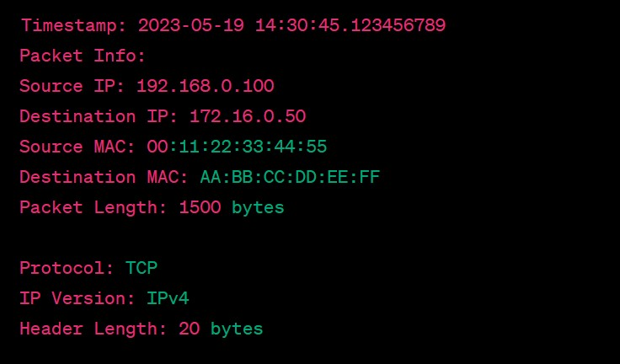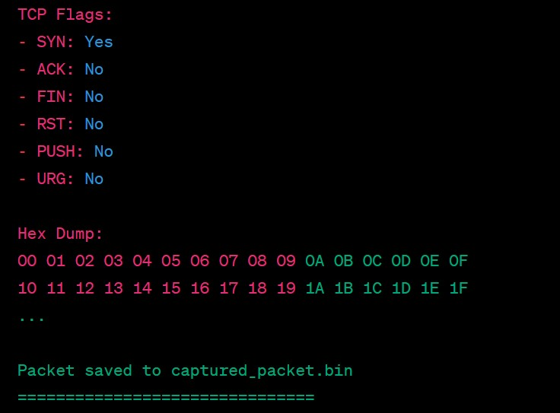

**Fig. 3 Output of the above code Part-1**

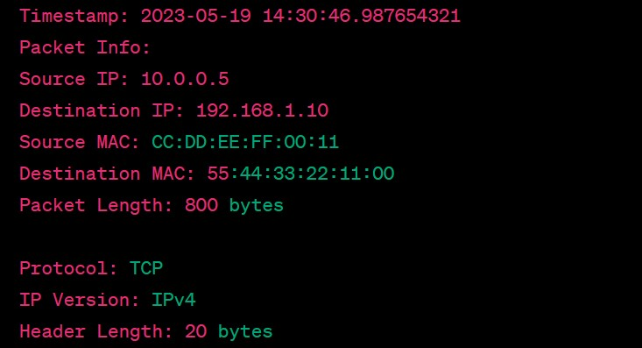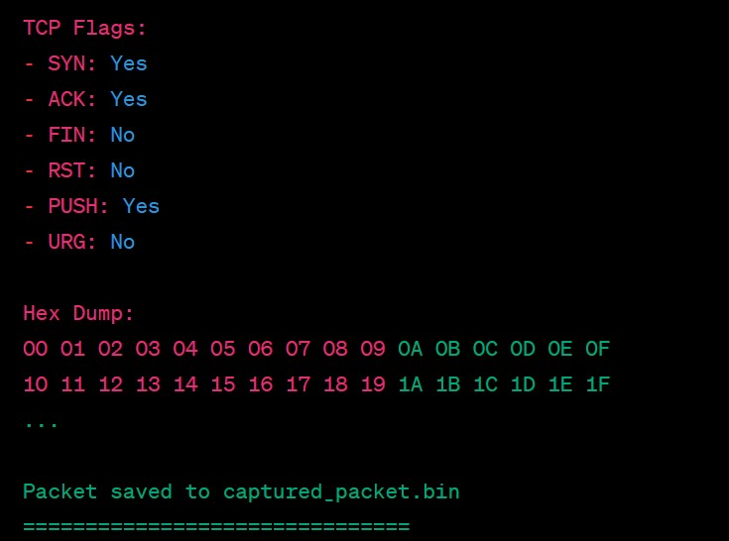

**Fig. 4 Output of the above code Part-2**

The output will continue to display the information for each captured packet in a similar format, including the timestamp, packet details, protocol information, TCP flags, hex dump, and the message confirming the packet has been saved to the file "**captured_packet.bin**". Each packet's information will be separated by the line of equal signs

(‘===============================’).

Please note that the example output above is for illustrative purposes, and the actual output may vary depending on the captured packets and your network configuration.

**5. CONCLUSION**

The use of a Network Packet Analyzer, such as the one implemented in the provided source code, offers several advantages and conclusions for network administrators, security professionals, and researchers.

Here is a detailed explanation of the conclusions and benefits of using a Network Packet Analyzer:

1. Network Traffic Analysis: A Network Packet Analyzer allows for in-depth analysis of network traffic. It captures and examines individual packets, providing insights into network protocols, communication patterns, and data exchange between devices. By studying packet-level details, administrators can identify network bottlenecks, optimize performance, and troubleshoot network issues.
2. Protocol Understanding: Network Packet Analyzers enable a comprehensive understanding of network protocols. They decode packet headers, extract information about source and destination IP addresses, MAC addresses, port numbers, and protocol-specific data. This understanding helps in analyzing network behavior, identifying anomalies, and detecting potential security threats.
3. Security Monitoring: Network Packet Analyzers play a crucial role in security monitoring and threat detection. By analyzing network packets, security professionals can identify malicious activities, such as unauthorized access attempts, suspicious data transfers, or network attacks. They can inspect packet payloads for malware signatures, detect network intrusions, and respond to security incidents promptly.
4. Performance Optimization: With a Network Packet Analyzer, administrators can assess network performance and optimize resource allocation. By analyzing packet-level data, they can identify latency issues, bandwidth consumption, or network congestion. This information helps in fine-tuning network configurations, allocating resources efficiently, and ensuring optimal network performance.
5. Troubleshooting Network Issues: Network Packet Analyzers serve as valuable troubleshooting tools. When network problems arise, administrators can capture and analyze packets to pinpoint the source of the issue. By inspecting packet headers, payload data, and examining packet flows, they can identify misconfigurations, faulty devices, or network errors that affect connectivity or performance.
6. Forensic Analysis: Network Packet Analyzers aid in forensic analysis during incident response investigations. By capturing packets during specific timeframes, investigators can reconstruct network activities, track the origin of malicious traffic, or gather evidence of unauthorized access. Packet-level details assist in understanding the sequence of events and uncovering the cause and impact of security incidents.
7. Network Monitoring and Baseline Establishment: By continuously capturing and analyzing network packets, administrators can establish baseline network behavior. They can monitor network trends, track usage patterns, and detect deviations from normal traffic patterns. This enables proactive network management, capacity planning, and the detection of abnormal behaviors that may indicate security breaches or performance degradation.

In conclusion, Network Packet Analyzers provide a powerful set of tools for network administrators and security professionals to gain visibility into network traffic, analyze protocols, monitor network performance, troubleshoot issues, detect security threats, and conduct forensic investigations. They empower organizations to maintain robust and secure networks, ensure optimal performance, and respond effectively to network-related challenges.

# 6. REFERENCES

1. "**Practical Packet Analysis: Using Wireshark to Solve Real-World Network Problems**" by Chris Sanders and Gary Scott Wright.
2. "**Wireshark Network Analysis: The Official Wireshark Certified Network Analyst Study Guide**" by Laura Chappell and Gerald Combs.
3. "**Network Forensics: Tracking Hackers through Cyberspace**" by Sherri Davidoff and Jonathan Ham.
4. "**TCP/IP Illustrated, Volume 1: The Protocols**" by W. Richard Stevens.
5. "**Computer Networks: A Systems Approach**" by Larry L. Peterson and Bruce S. Davie.
6. Wireshark Documentation ( available at <https://www.wireshark.org/docs/>).